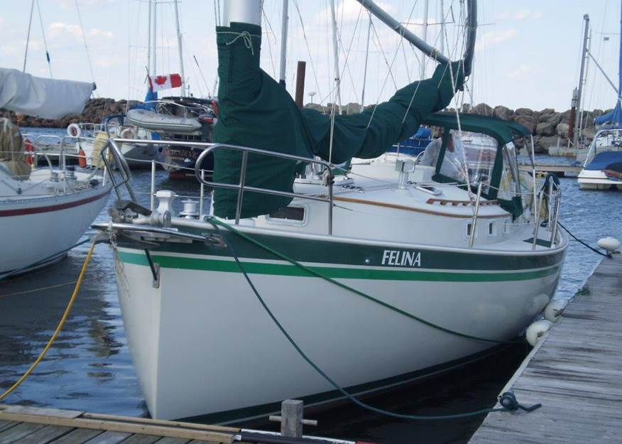**1984 Nonsuch 30 Ultra**

**'Felina'** is a two-owner vessel, fresh-water sailed from 1984 to 2009, purchased by present owners in April of 2010 and sailed out of Shediac, N.B.  She has a 33hp Westerbeek 4 cylinder engine with approx. 500 hours.  The main is a lightly used 2006 Doyle, re-furbished in 2014 by Doyle and a 2014 Doyle Stack Pack (Ed Botterell).  
  
This vessel has been meticulously maintained, is clean and dry, bilges like new.  Her condition enhances the Hinterhoeller standards of construction and finish.

Equipment includes:  
  
Raymarine 4000 Autopilot, with remote, Raymarine ST60 Depth and ST60 Speed.  
Datamarine Annometer  
Electric halyard, Electric windlass with two CQR anchors. One with 200 ft. all chain rode and the other with 200 ft. nylon rode.  
Stainless steel Dodger with Bimini  
Fuel tank removed, cleaned and tested in 2011  
All new running rigging and Garhauer blocks (2013), Topping lift (2010)  
Horizon DCS VHF with cockpit remote (2010)  
Swim platform by Stainless Outfitters (2011), Dingy davits  
Two battery banks, Bank 2 three 2013 batteries, Bank 1 two Optimas AMG   
Xantrax battery charger 40 amp(2013) with remote   
Refrigeration, propane hot water and three burner stove   
All winches are self-tailing with Lewmar clutches  
Recently re-finished teak and holly sole  
Winter cover and aluminum frame   
Bottom re-epoxied in the late 1990’s.  Sanded and ready for bottom paint  
Factory cradle and all factory manuals, commercial 22,000 GVW trailer available

Asking 65,000 C$ (excludes trailer)

Berth at Pte.du Chene Available        Contact 506-386-3730